**LINUX FILE SYSTEM**

The Linux file system is a multifaceted structure comprised of three essential layers. At its foundation, the Logical File System serves as the interface between user applications and the file system, managing operations like opening, reading, and closing files. Above this, the Virtual File System facilitates the concurrent operation of multiple physical file systems, providing a standardized interface for compatibility.

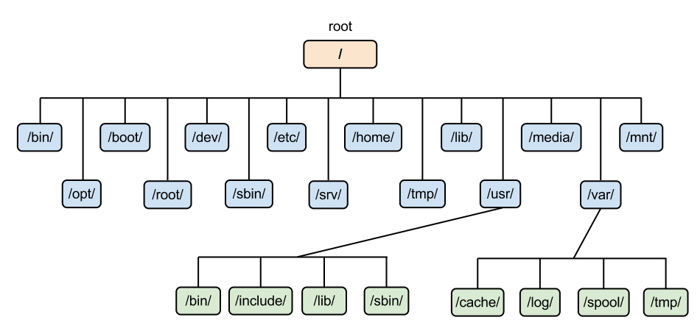

Linux File System

**Roles of Linux File System:**

* The data is organized and can be easily located.
* - The data can be easily retrieved at any later point in time.
* -The integrity of the data is preserved.

**Characteristics of a File System:**

* **Space Management**: how the data is stored on a storage device. Pertaining to the memory blocks and fragmentation practices applied in it.
* **Filename**: a file system may have certain restrictions to file names such as the name length, the use of special characters, and case sensitive-ness.
* **Directory**: the directories/folders may store files in a linear or hierarchical manner while maintaining an index table of all the files contained in that directory or subdirectory.
* **Metadata**: for each file stored, the file system stores various information about that file’s existence such as its data length, its access permissions, device type, modified date-time, and other attributes. This is called metadata.
* **Utilities**: file systems provide features for initializing, deleting, renaming, moving, copying, backup, recovery, and control access of files and folders.
* **Design**: due to their implementations, file systems have limitations on the amount of data they can store.

**Structure of Linux:**

* **/ (root filesystem):** It is the top-level filesystem directory. It must include every file needed to boot the Linux system before another filesystem is mounted. Every other filesystem is mounted on a well-defined and standard mount point because of the root filesystem directories after the system is started.
* **/boot:** It includes the static kernel and bootloader configuration and executable files needed to start a Linux computer.
* **/bin:** This directory includes user executable files.
* **/dev:** It includes the device file for all hardware devices connected to the system. These aren't device drivers; instead, they are files that indicate all devices on the system and provide access to these devices.
* **/etc:** It includes the local system configuration files for the host system.
* **/lib:** It includes shared library files that are needed to start the system.
* **/home:** The home directory storage is available for user files. All users have a subdirectory inside /home.
* **/mnt:** It is a temporary mount point for basic filesystems that can be used at the time when the administrator is working or repairing a filesystem.
* **/media:** A place for mounting external removable media devices like USB thumb drives that might be linked to the host.
* **/opt:** It contains optional files like vendor supplied application programs that must be placed here.
* **/root:** It's the home directory for a root user. Keep in mind that it's not the '/' (root) file system.
* **/tmp:** It is a temporary directory used by the OS and several programs for storing temporary files. Also, users may temporarily store files here. Remember that files may be removed without prior notice at any time in this directory.
* **/sbin:** These are system binary files. They are executables utilized for system administration.
* **/usr:** They are read-only and shareable files, including executable libraries and binaries, man files, and several documentation types.
* **/var:** Here, variable data files are saved. It can contain things such as MySQL, log files, other database files, email inboxes, web server data files, and much more.